Frame

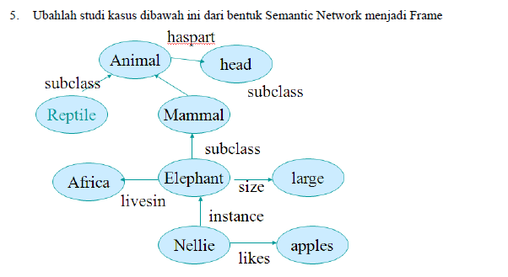

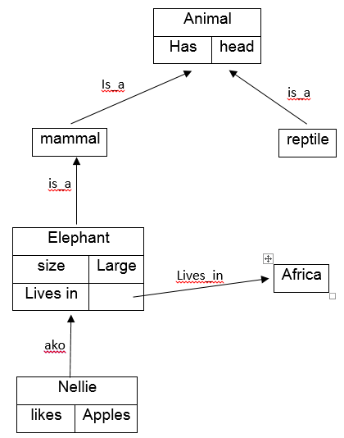

|  |
| --- |
| **attribute(animal,has,head).**  **attribute(elephant,size,large).**  **attribute(elephant,lives_in,africa).**  **attribute(nellie,likes,apples).**  **is_a(mammal,animal).**  **is_a(reptile,animal).**  **is_a(elephant,mammal).**  **ako(nellie,elephant).**  **subclass(Class1,Class2):-is_a(Class1,Class2).**  **subclass(Class1,Class2):-is_a(Class1,Class3),subclass(Class3,Class2).**  **aninstance(Obj,Class):-ako(Obj,Class).**  **aninstance(Obj,Class):-ako(Obj,Class1),subclass(Class1,Class).**  **value(Obj,Property,Value) :-attribute(Obj,Property,Value).**  **value(Obj,Property,Value) :-aninstance(Obj,Class).**  **attribute(Class,Property,Value).** |

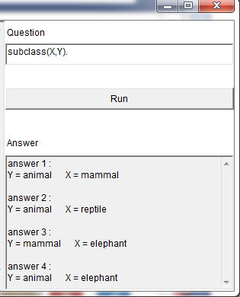

Instance :

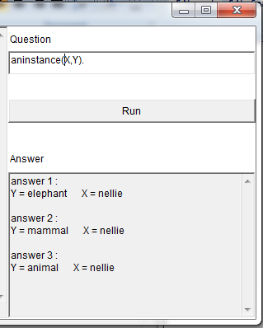

Attribute :

